School of Informatics & IT

Diploma in Cybersecurity and Digital Forensics

CDF3C01 – Incident Response and Management (ICRM)

Lab 4 – Security Incident Response Management II

Learning Outcomes
By the end of this practical lesson, the student should be able to demonstrate the following items:
- Customise the Wireshark GUI to display required information needed during the analysis.
- Apply search filters to only display what is required during the analysis.
- Identify hosts and users within a Wireshark Packet Capture (PCAP) file.

Tasks

Background / Scenario
Wireshark is a free protocol analyzer that can record and display packet captures (PCAPs) of network traffic. This tool is used by IT professionals to investigate a wide range of network issues, and as a security analyst, Wireshark is often used to review traffic generated from security incidents.
Note: These trainings are a subset of the Unit42 Palo Alto Network Wireshark Training Guides (https://unit42.paloaltonetworks.com/tag/wireshark/)

Introduction to Wireshark

Customizing Wireshark - Changing Your Column Display
Typically attacks that involve malware during security incidents are based on web traffic, and this channel is commonly used as a medium for data exfiltration / command and control (CnC) activities. Wireshark’s default column is not ideal when investigating such traffic, and therefore we need to customize it to provide a better view of the activity.
Ideally what we need to set up are the following:
- Date & Time in UTC
- Source IP + Source Port
- Destination IP and Destination Port
- HTTP host
- HTTP/HTTPS server
- Info

Step 1: Launch Wireshark
- Boot up the ICRM-CENTOS8 Linux VM, and login with the following credentials:
- Username: root
- Password: enjoyit123
- Click on the ‘Activities’ column and launch the Wireshark application (left sidebar, 3rd icon from the top)
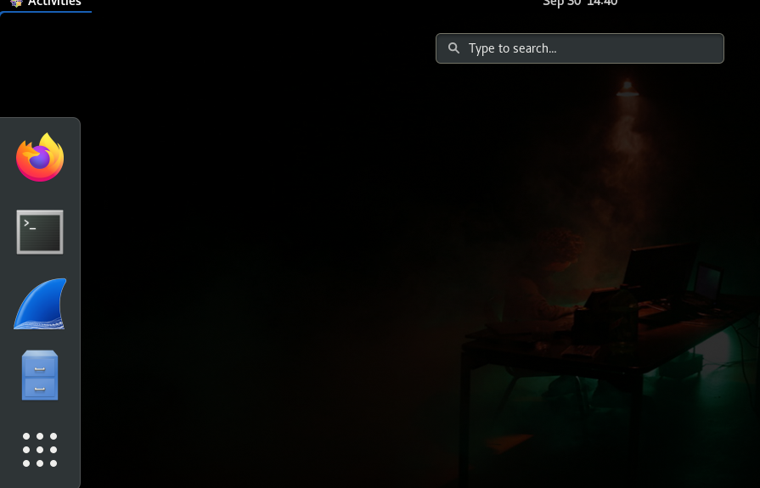
- When the application is launched, go to File > Open
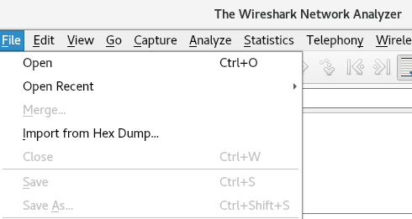
- Go to /root/wireshark_files folder and load up the traffic-for-wireshark-column-setup.pcap file.
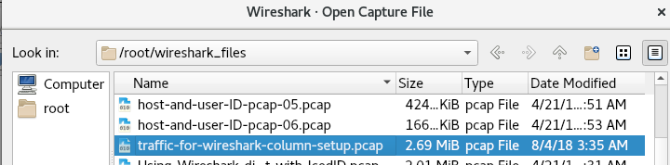

Step 2: Removing/Hiding Columns
By default, the following columns are set on Wireshark:
- No. - Frame number from the beginning of the pcap. The first frame is always 1.
- Time - Seconds broken down to the nanosecond from the first frame of the pcap. The first frame is always 0.000000.
- Source - Source address, commonly an IPv4, IPv6, or Ethernet address.
- Destination - Destination address, commonly an IPv4, IPv6, or Ethernet address.
- Protocol - Protocol used in the Ethernet frame, IP packet, or TCP segment (ARP, DNS, TCP, HTTP, etc.).
- Length - Length of the frame in bytes.
As we no longer need the No. column (due to the existence of the Time column) and Length column, perform the following steps:
- Right-click on any of the column headers, then select “Column Preferences…”
- Select the ‘No.’ column and remove it by pressing the ‘-‘ button.
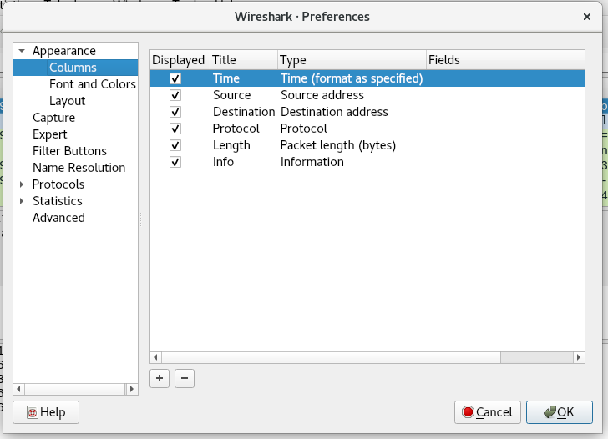

- Repeat the same step for the Length column as well.

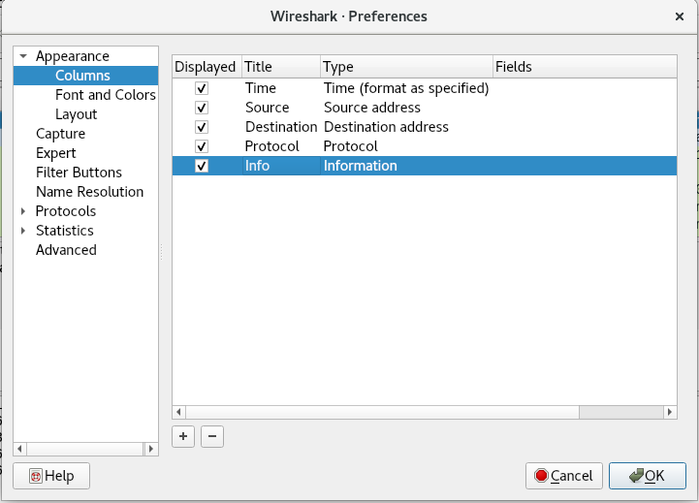

Step 3: Adding Columns
- To add a new column, press the ‘+’ button and a new entry will appear within the list of columns:
- Add on the following columns:
  - Title: Destination Port, Type: Dest port (unresolved)
  - Title: Source Port, Type: Src port (unresolved)
- Arrange the columns based on the screenshot below, and press OK:
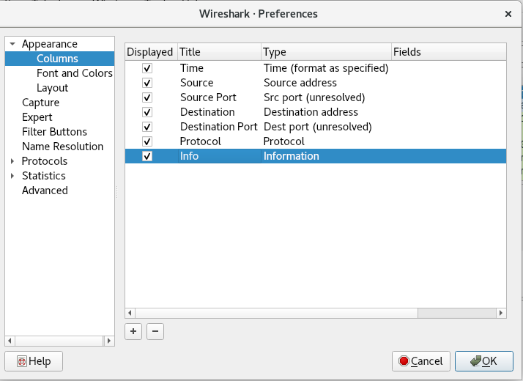

- To make the results appealing for viewing, right-click on the newly added columns and select ‘Align Left’:
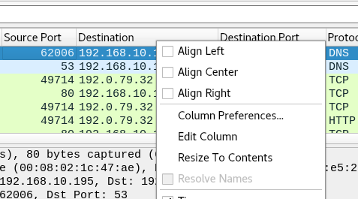

Step 4: Changing Time to UTC
- Go to View > Time Display Format and change the value from “Seconds Since Beginning of Capture” to “UTC Date and Time of Day”.
- Use the same menu path to change the resolution from “Automatic” to “Seconds”
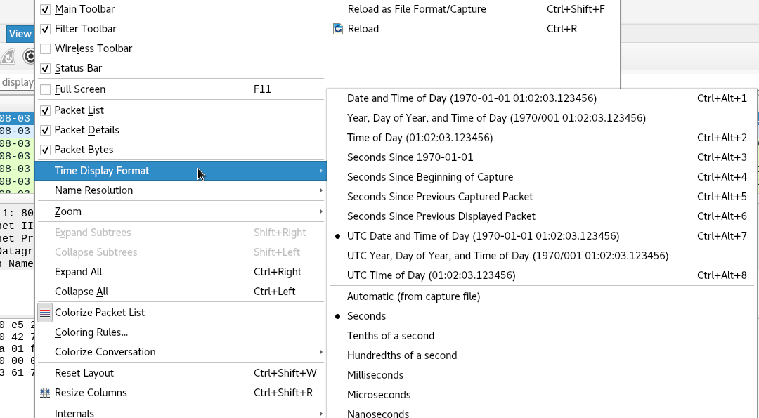

Step 5: Adding Custom Columns
Wireshark has the capability to add custom columns based on almost any value found in the frame details window. Using the example PCAP file above, we can add domain names used in HTTP and HTTPS traffic to our Wireshark column display.
- Use the Wireshark filter http.request and examine the frame details window (region that is boxed in red within the screenshot below):
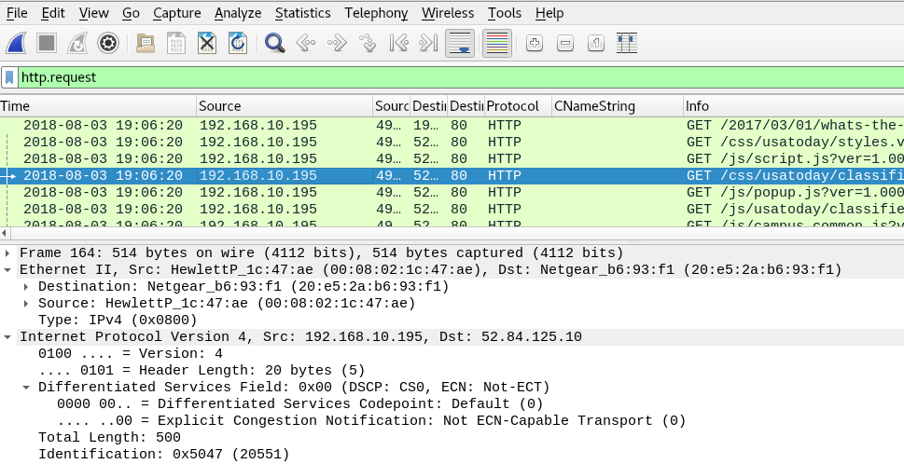

- Expand the line titled “Hypertext Transfer Protocol”
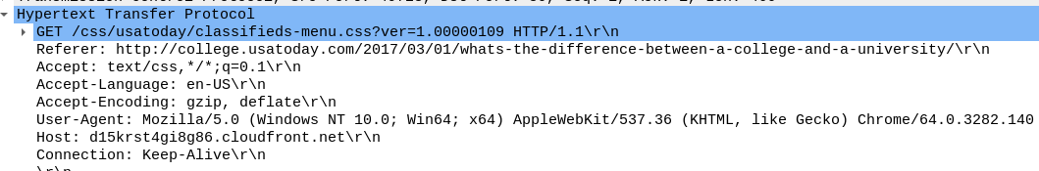
- Find the “Host” header value and right-click on the value, followed by click on the “Apply As Column”
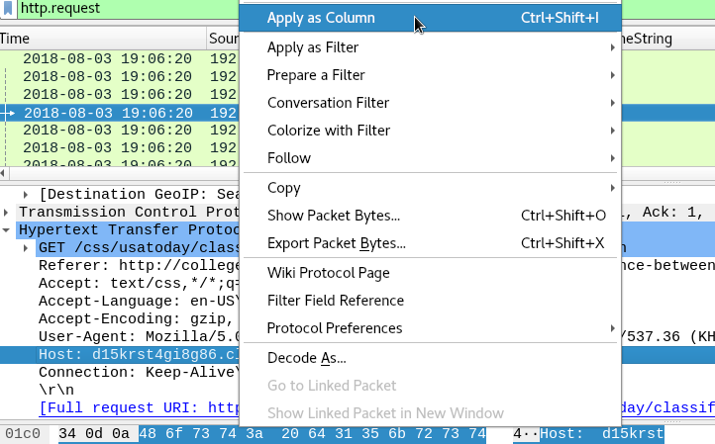
- A ‘Host’ column is added to your Wireshark columns display, showcasing the domain names of the servers.
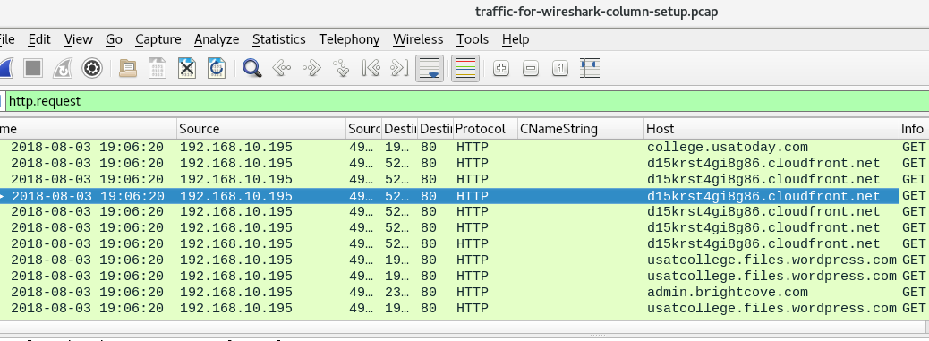

Using Wireshark – Display Filter Expressions
As PCAP files contain a wealth of information regarding a security incident, it is essential that as a security analyst, filters are required to sift out the information and gather what is needed as part of the incident investigation.

Step 1: Crafting a display filter
As mentioned earlier, attacks that involve malware during security incidents are based on web traffic and one of the most useful filters in Wireshark is to take note of all HTTP requests that are sent within the captured traffic.
- To filter out only http requests, type the following filter within the “Display Filter” bar:
  - http.request
Notice that when typing the filter above, there will be a dropdown list of other filters that are more refined and specific to use. But for now, let’s just use that filter.
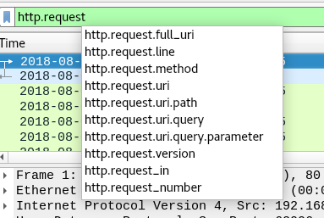
- Press Enter and your results will be filtered:
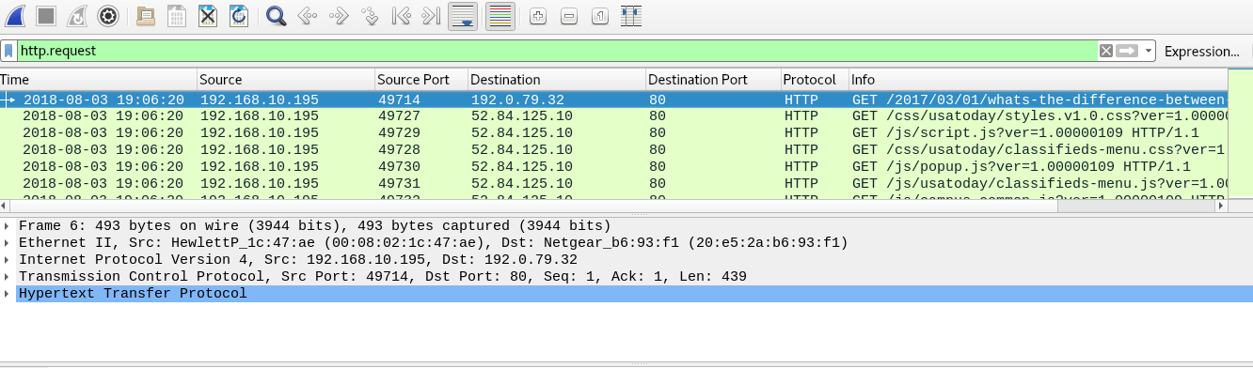

Step 2: Combining multiple filters
Let’s say that you want to view traffic only from specific destination IP addresses (192.0.73.2 and 93.184.216.180):
- Type the following filter within the “Display Filter” bar:
  - ip.dst_host == 192.0.73.2 || ip.dst_host == 93.184.216.180
What does the display filter above mean?
- Based on your understanding, craft out Wireshark display filters based on the following requirements:
Requirement | Wireshark Filter
Display only DNS (Port 53) and HTTP/HTTP traffic
Display only network traffic of IP addresses within the 192.168.10.0/24 subnet
Display only successful HTTP responses (HTTP/1.1 200 OK) that are not via the OCSP protocol.
Only DNS queries that contain the words “facebook” or “twitter”
Display HTTP requests that were initiated to fetch Javascript libraries (.js files) from the IP address 192.168.10.195.

Identifying Hosts and Users
At the start of every investigation, it is important to find out who are the victims in this security incident (based on their IP addresses) and the available public servers/hosts that are involved. This is important as it will determine the type of display filters that you will need to craft out to aid in your investigation. Information of the victim such as the device model and operating systems can be obtained from 3 locations:
- DHCP/BOOTP/NBNS Traffic
- HTTP Traffic
- Kerberos Traffic (for Windows Active Directory environment)

Step 1: Host Information from DHCP/BOOTP/NBNS Traffic
- When the Wireshark application is launched, go to File > Open

- Go to /root/wireshark_files folder and load up host-and-user-ID-pcap-01.pcap file.
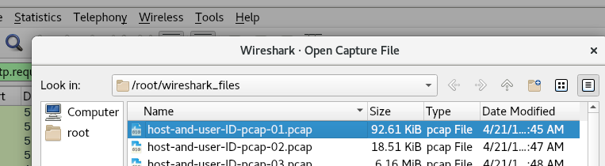
- Filter out only DHCP traffic within the PCAP file using the Display Filter.
Which one of the IP addresses do you think is the client, and the server? Why?
For the IP address that you have identified as the server, what network/host equipment do you think it is?
The NetBIOS Name Server (NBNS) is one of the protocols that a Windows computer will use to look for a host on the internal network, in the event whereby the host’s IP address cannot be resolved via the internal DNS server. NBNS Traffic not only shows the IP address of the victim, but also shows the machine name of the victim, which greatly assists in the containment of the security incident.
- Go to /root/wireshark_files folder and load up host-and-user-ID-pcap-02.pcap file.
- Filter out only NBNS traffic within the PCAP file using the Display Filter, and fill up the following table:
MAC Address of Victim
IP Address of Victim
Victim Hostname

Step 2: Device/OS information from HTTP Traffic
- When the Wireshark application is launched, go to File > Open

- Go to /root/wireshark_files folder and load up host-and-user-ID-pcap-03.pcap file.
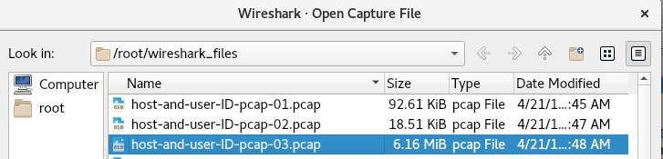
- Filter out only HTTP requests and do not include requests that involve the SSDP protocol within the PCAP file using the Display Filter.
- For HTTP traffic, you can also follow the stream of data for both requests and responses by right-clicking on a HTTP request and going to Follow > TCP Stream
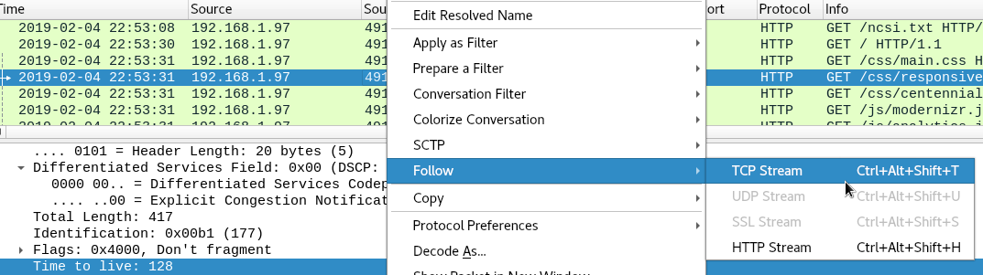
- One of the easiest ways to identify the victim’s OS system is to look at the User-Agent header for all HTTP requests, as each web browser has its own signature, even in different operating systems. (e.g Firefox for Linux has a different User-Agent string value than Firefox for Windows)
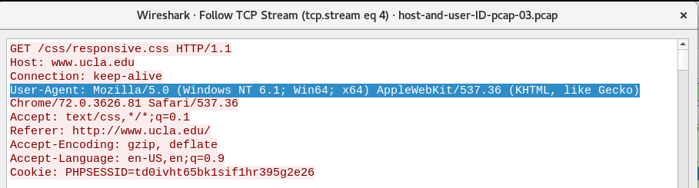
Based on the User-Agent, what operating system is the victim running on his/her PC?
Load up the host-and-user-ID-pcap-05.pcap file in Wireshark and identify the OS/device that the victim was using.

Step 3: Windows User Account from Kerberos Traffic (optional)
The Kerberos Protocol is a computer-network authentication protocol that allows computers to access resources over the network using tickets instead of actual usernames and passwords. It is built based on symmetric key cryptography and requires a trusted third party.
- When the Wireshark application is launched, go to File > Open

- Go to /root/wireshark_files folder and load up host-and-user-ID-pcap-06.pcap file.
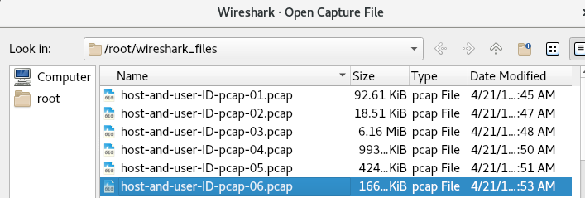
- Apply the following filter on the PCAP file: kerberos.cname_string
- Under the Frame details section:
- Expand the Kerberos section and the subsections (specifically Kerberos > as-req > req-body > cname > cname-string)
- Select the line with CNameString: johnson-pc$
- Right-click on it and select ‘Apply as Column’
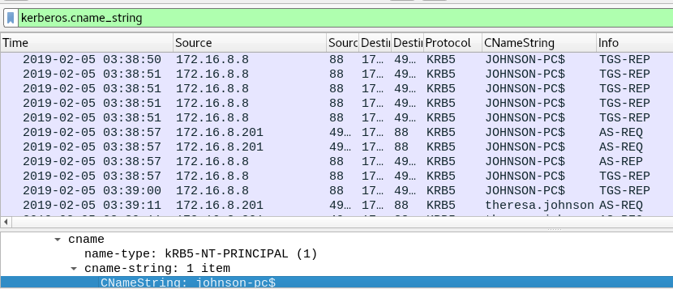
CNameString values for hostnames end with a dollar-sign symbol ($), while user account names do not. Based on this, what would be the modified display filter to only show user account names?

